**Project Title:**

Expense Manager

Done by:

Bheri Saiteja_20BCE7458

C Giri Teja_20BCN7153

AmanDhakar_20BCR7078

Saga Naga Sai Akhilesh_20BCE7010

**1. INTRODUCTION**

**1.1 Overview**

The Expense Manager Team Project is a robust and modern application designed and built as part of an externship program. The application serves users in managing a unique entity known as "expense". It was developed using the latest Jetpack Compose and Kotlin programming language, following the MVVM architecture.

**1.2 Purpose**

The application is designed to help users manage "expense" items, which can be added, edited, and deleted. It also provides functionality to fetch all expenses and calculate the sum of the expenses for the current month. It offers user authentication through Google accounts and profile management features.

**2. LITERATURE SURVEY**

**2.1 Existing problem**

Expense management is an area that often involves tedious manual processes and is prone to errors, unauthorized bookings, inaccurate receipts, lack of visibility into spending trends, poor communication, loss or misplacement of receipts, and disparate data sources. These problems can lead to inefficiency, financial loss, and frustration among staff.

**2.2 Proposed solution**

Expense manager proposes a solution that digitalizes and automates the management of expenses ("expense" items in the app). It offers user authentication, profile management, and expense management features to streamline and simplify the process.

**3. THEORITICAL ANALYSIS**

**3.1 Block Diagram**

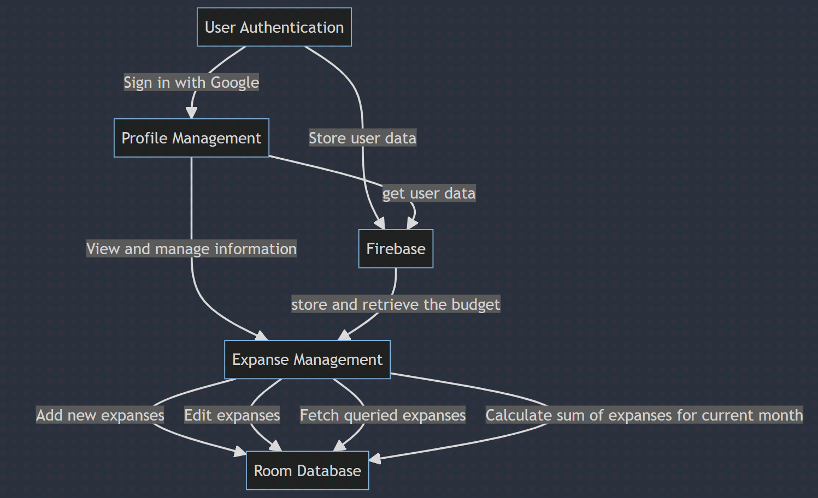

**3.2 Hardware / Software Designing**

The application is developed in Kotlin and uses Jetpack Compose for the UI. It follows the MVVM architecture and uses Room for database operations. The project is structured into several packages: core (base code and utility functions), data (data handling and database operations), di (dependency injection), domain (business logic, data classes, use-case classes), and presentation (UI logic).

**4. FLOWCHART**

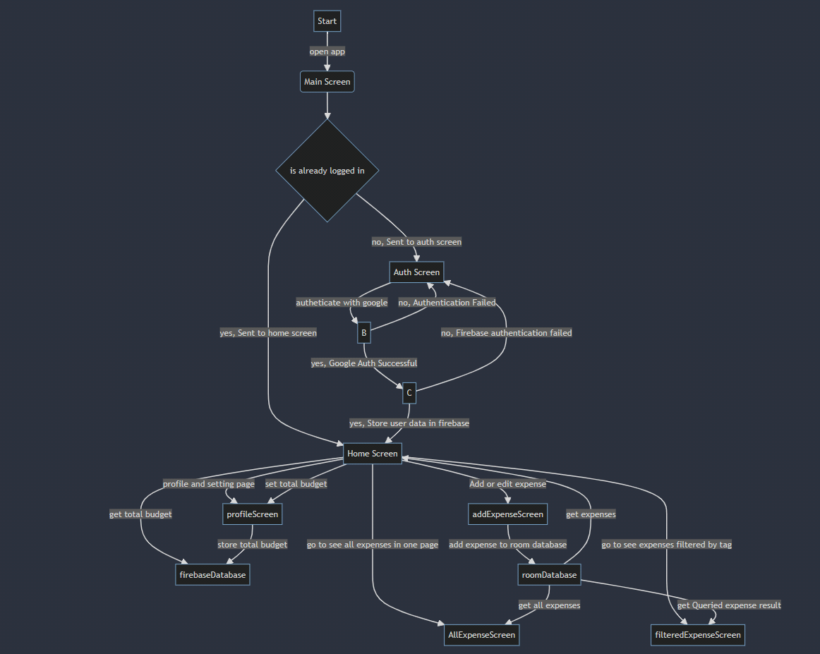

**5. RESULT**

The application offers a system for user authentication, profile management, and expense management. Users can add new expenses, edit existing ones, and delete any they no longer need. The application also offers functionality to fetch all expenses and calculate the sum of the expenses for the current month.  
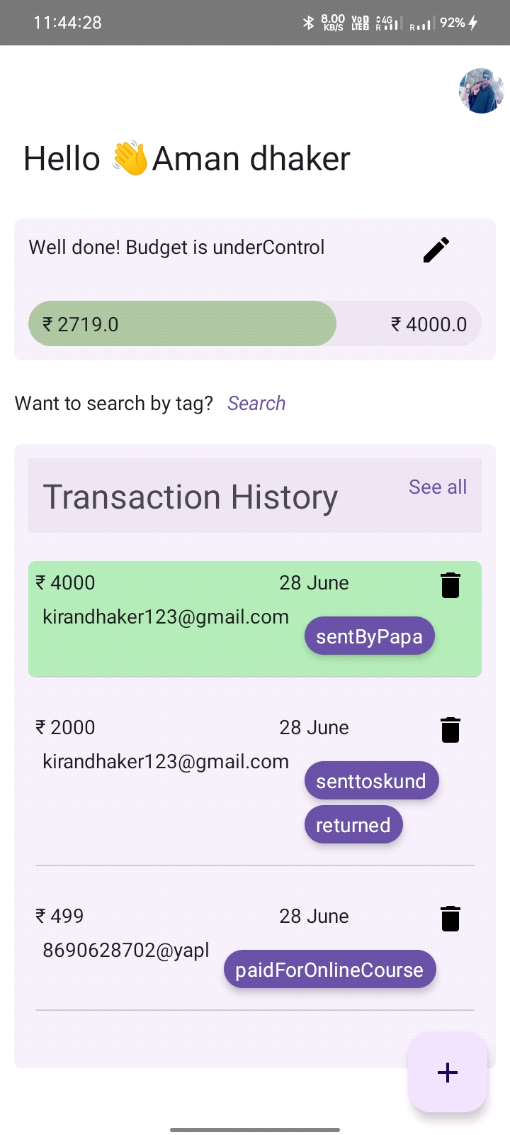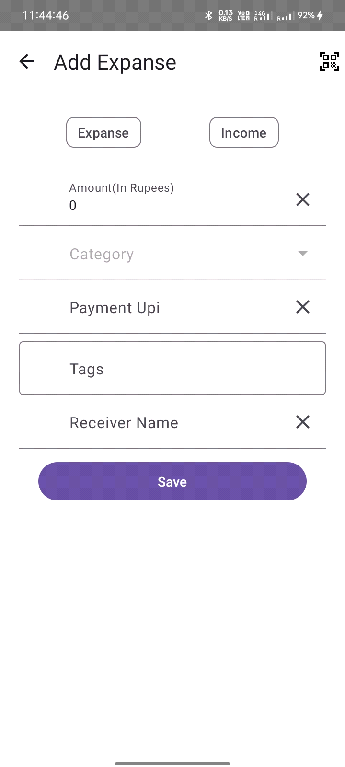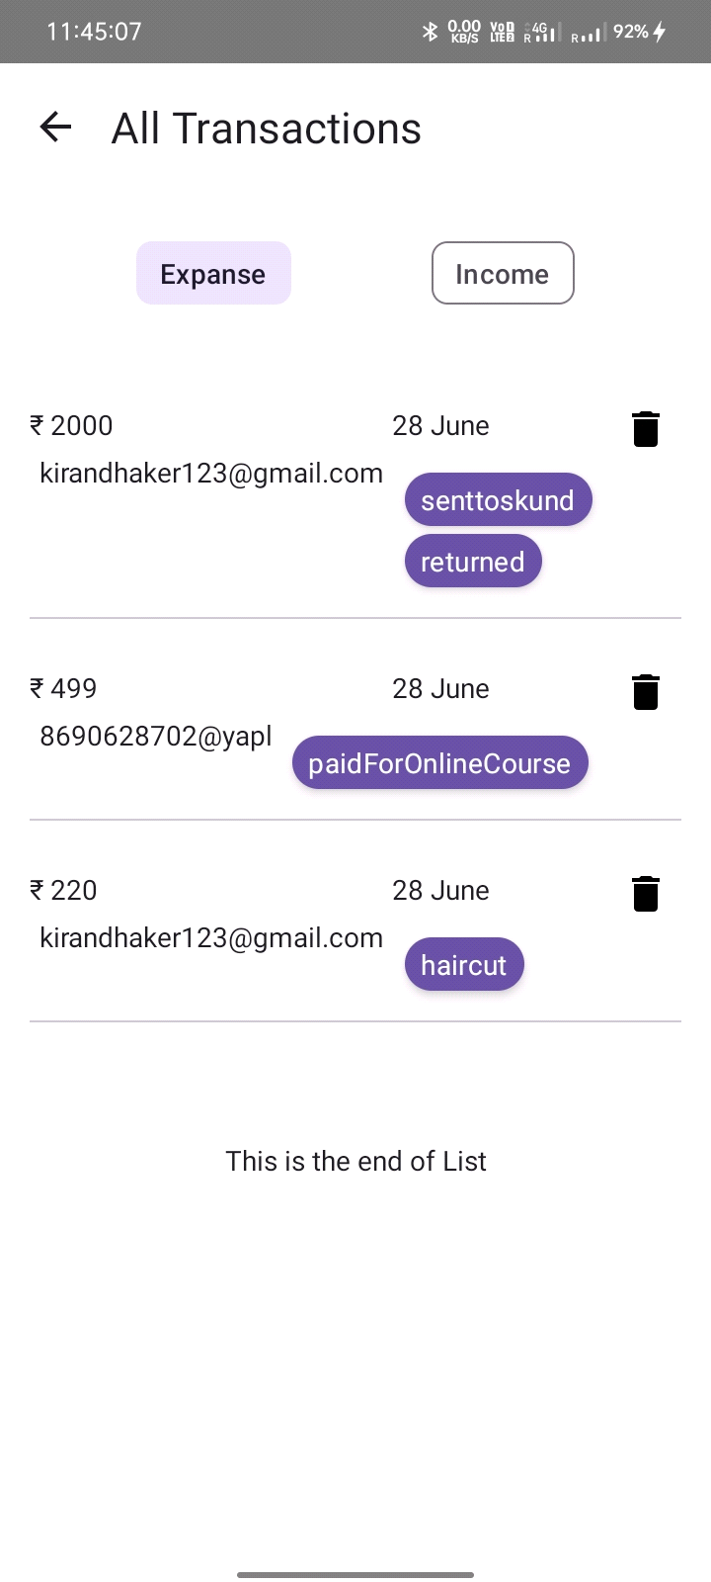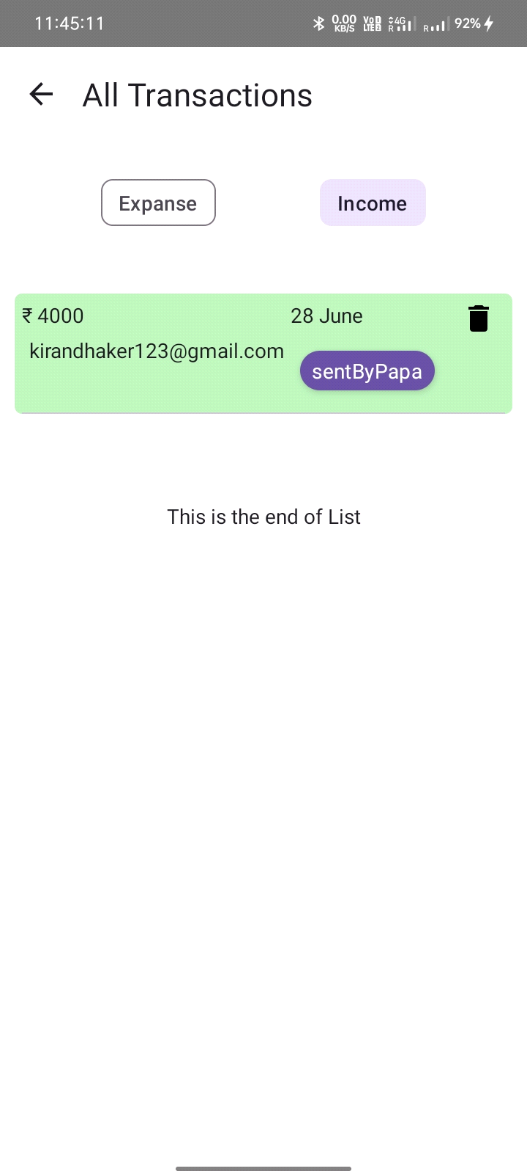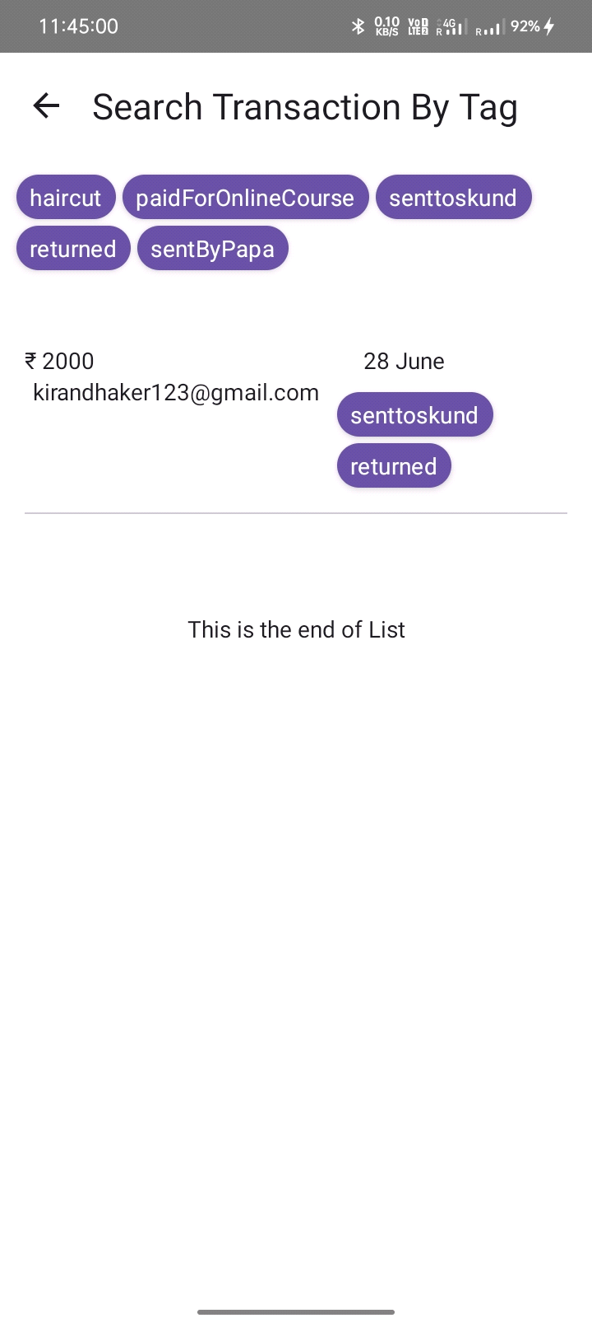

**6. ADVANTAGES & DISADVANTAGES**

Advantages:

* **Easy to Use**: The application is designed with user-friendliness in mind. The user authentication process is streamlined and the management of profiles and expanses is designed to be intuitive.
* **Effective Expense Tracking**: The application's core functionality revolves around managing expanses. Users have the ability to add new expanses, edit existing ones, and delete any they no longer need. The application also offers functionality to fetch all expanses and calculate the sum of the expanses for the current month.
* **Modern Technologies**: The application uses the latest Jetpack Compose and Kotlin programming language, which are modern, robust, and efficient tools for Android development. It follows the MVVM architecture pattern, which promotes a clean and organized code structure.
* **Scalability and Maintainability**: The structure of the project, with its clearly delineated packages for core functionalities, data handling, business logic, presentation logic, and dependency injection, can make it easier to maintain and scale in the future.
* **Google Account Integration**: The ability to sign in using a Google account makes it easy for users to get started and enhances the user experience.
* **Open Source and Community Engagement**: The project is open-source and encourages contributions from the developer community. This can lead to continuous improvements and additions to the project based on the collective input of the community.
* **Potential for Future Features**: The project is under active development, and there are plans for future updates such as user bank balance tracking and transaction history. This suggests that the application could become even more useful over time.

Disadvantages:

* **Lack of Broad Integration**: While this application is designed for managing "expanse" items, it might not be integrated with other financial systems or apps that a user might already be using. Users might have to manually enter information that could have been imported from other services.
* **Limited Feature Set**: Currently, the application primarily focuses on tracking and managing expanses. It does not have features like budgeting, investment tracking, or detailed financial analysis that other comprehensive finance management apps might offer.
* **Dependence on User Input**: The accuracy and usefulness of the app depend heavily on the user consistently and accurately inputting their expenditure data. If the user forgets or inaccurately enters data, the utility of the app diminishes.
* **Security and Privacy**: As the app involves handling potentially sensitive financial data, there could be concerns about data security and privacy. If not handled properly, this could be a significant disadvantage.

**7. APPLICATIONS**

The Expense Manager Project, which focuses on expense management, can have multiple applications in various contexts. Here are a few potential applications:

* **Personal Finance Management**: The primary application of this project is to help individuals manage their personal finances. By tracking expanses, users can gain a better understanding of their spending habits, which can help them budget more effectively and save money.
* **Small Business Expense Tracking**: Small businesses or freelancers could potentially use this application to track their business expenses. This could help them understand their cost structure, manage their cash flow, and simplify their tax preparation process by having all their expense data in one place.
* **Travel Expense Tracking**: For individuals who travel frequently, either for business or personal reasons, the application could be used to track travel-related expenses. This can simplify the process of submitting travel expense reports or claiming tax deductions related to travel expenses.
* **Financial Literacy and Education**: By actively using the application to track and manage their expenses, users could potentially improve their financial literacy and gain a better understanding of personal finance management.

**8. CONCLUSION**

The Expense Manager Project provides an effective solution for managing expenses, featuring user authentication, profile management, and the ability to manage 'expense' items. The application is a testament to the capabilities of modern Android development techniques, libraries, and best practices.

**9. FUTURE SCOPE**

The application is still under active development, with plans for future updates.

One upcoming feature includes getting user bank balance and transaction history in the app, so that users can track offline and do not need to add transactions manually.

**10.**

**10.1 References**

<https://developer.android.com/>  
  
<https://m3.material.io/>  
  
<https://stackoverflow.com/>  
  
<https://medium.com/>

[**https://firebase.google.com/docs/**](https://firebase.google.com/docs/)

**10.2 APPENDIX**

**source code**

<https://github.com/AMANDHAKAR191/KotlinExternshipTeamProject>